Research and Community Service Implementation in 2020

By: Chalid Luneto. April 1, 2020. 09:00:00

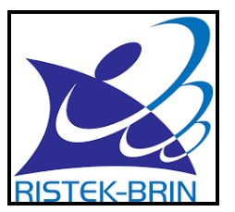(Research and Technology – National Research and Innovation Agency)

Next is the information of Research and Community Service Implementation in carrying out the activities must attend to the following things:

1. Research and Community Service 2019 proposal of 2020 funding implemented after the contract;

2. Research on multiple years with the 2019 contract that is asserted to be implemented without waiting for the amendment of the multi-year research contract of 2019;

3. In connection with the outbreaks of COVID-19, which continue to increase in Indonesia, research and community service implementers can pay attention to the safety aspects of researchers/servants, other people, and the environment during the Research and Community Service implementation by referring to the National Standards for Higher Education according to the Regulation of the Minister of Research, Technology, and Higher Education Number 44 of 2015;

4. Related to point 3 above, the following are requested:

a). Inform all researchers and service implementers to prioritize maintaining the health and safety of themselves, others, and the environment;

b). Identify researchers and service implementers who are unable to carry out research and service activities and report them to the Director of Research and Community Service;

c). Identify researchers and service implementers focusing on healthcare, food, engineering, and social humanities who have the potential and wish to substitute the research and service towards COVID-19, to then submit a revision proposal to the Director of Research and Community Service.

5. Other things that have not been regulated in this letter will be explained in the following letter following further progress.

Source: SIMLITABMAS (310320)